**IBM Security Identity Governance**

**And Intelligence**

**IGI Email Notification Lab Guide (Lab01)**

**5.2.x**

**David Edwards**

Version 0.2

July 2017

**Document Purpose**

This document provides the instructions for running the IGI Email Notification labs.

For any comments/corrections, please contact David Edwards ([davidedw@au1.ibm.com)](mailto:davidedw@au1.ibm.com)).

**Document Conventions**

The following conventions are used in this document:

* A step to be performed by the student.

A note, some special information or warning.

A piece of code

Normal paragraph font is used for general information.

The term “IGI” is used to refer to IBM Security Identity Governance and Intelligence.

**Document Control**

|  |  |  |  |
| --- | --- | --- | --- |
| **Release Date** | **Version** | **Authors** | **Comments** |
| 20 Feb 2017 | 0.1 | David Edwards | Initial version |
| 28 Jul 2017 | 0.2 | David Edwards | Updated for training environment v4 (split VA/Data) and IGI 5.2.3 |

**Table of Contents**

1 Introduction to the Lab 4

2 Lab Pre-Requisites 5

2.1 Expected Knowledge 5

2.2 Standard Lab Setup 5

2.3 Additional Lab Setup 5

3 Lab Instructions 6

3.1 Part 1 – Explore the Notification System 6

3.1.1 Open the Notification System 6

3.1.2 Explore the Notification Settings tab 6

3.1.3 Explore the Notification Templates tab 8

3.1.4 Explore the Notification Monitoring tab 9

3.2 Part 2 – Add Notifications to an Access Request Workflow 10

3.2.1 Open the Process Designer 10

3.2.2 Add Notification to the Activities 11

3.2.3 Test the Notification Configuration 14

3.3 Part 3 - Modify Templates and Test 17

3.3.1 Modify the Request Generation Template 17

3.3.2 Test the Template Modifications 18

Notices 20

# Introduction to the Lab

The primary means of notification in an identity management system is email. IBM Security Identity Governance and Intelligence (ISIGI or IGI) leverages email for notification of events or actions required.

Some of this notification is provided out-of-the-box bit some requires configuration. IGI 5.2.2 introduced a flexible notification system that provides both email and SMS support that can be added to activities in workflow.

This lab will look at this new notification system and walk through setting up, testing and customizing the email notifications in an access request workflow.

The parts of the lab are:

1. Explore the Notification System
2. Add Notifications to an Access Request Workflow and Test
3. Modify Templates and Test

# Lab Pre-Requisites

This section defines the lab pre-requisites.

## Expected Knowledge

This lab assumes the following knowledge has been acquired before attempting the labs:

* Familiarity with the IGI Administrative Console and Service Center
* Familiarity with the Access Request mechanisms and UI modules
* Familiarity with the Process Designer, Workflows and Activities

This knowledge can be gained via the introductory (Foundation) training of IGI.

## Standard Lab Setup

This lab uses the standard IGI training lab. Setup for this lab is described in the document ***Lab00 - IGI Lab Environment Setup Guide***.

These documents describe the standard training environment used for the IGI labs and the steps to prepare for this lab.

## Additional Lab Setup

For this lab, an email client for Patricia Whiteman ([pwhiteman@igi.ibm.com)](mailto:pwhiteman@igi.ibm.com)) will be required.

Appendix C in the document ***Lab00 - IGI Lab Environment Setup Guide*** contains instructions to setup some mail clients (Mac Mail and Thunderbird).

If you are using the Windows Server VM, you will need to configure Thunderbird. or email client settings. A link to Thunderbird is on the desktop and in the system tray of the Windows Server VM.

If you are running the labs on local VMs, you can use your own mail client.

# Lab Instructions

## Part 1 – Explore the Notification System

This part of the lab will explore the Notification System that was significantly enhanced in IGI 5.2.2.

### Open the Notification System

The steps are:

* Open the **IGI Administrative Console** (login with admin/admin)
* Open **Access Governance Core**
* Go to **Configure > Notifications**

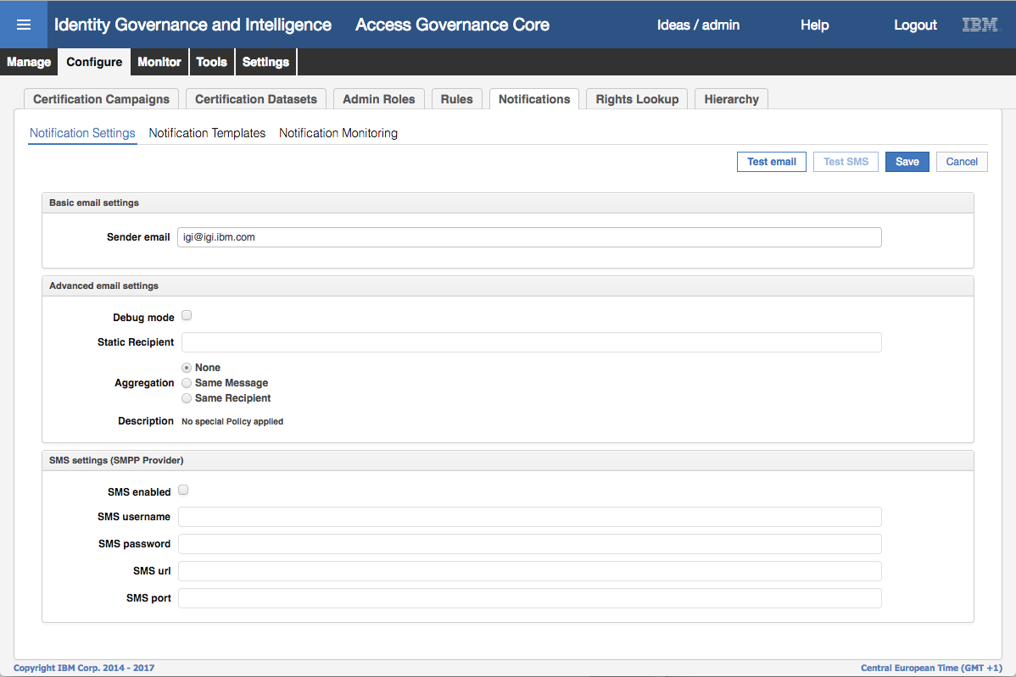

### Explore the Notification Settings tab

The default tab shown is the Notification Settings tab. It contains:

* Basic email settings – the default sender email
* Advanced email settings
  + Debug mode – when selected it will only send emails to the Static Recipient.
  + Aggregation – what level of email consolidation to set
  + Description – a description of the aggregation setting selected
* SMS settings – whether SMS is enabled and the SMS settings if enabled

The tab also has functions to test email and SMS configuration (if enabled). The following steps will use the Test email button to check you’ve got your email client setup successfully (needed for later labs).

* Click the **Test email** button
* On the Test email dialog enter the values as shown

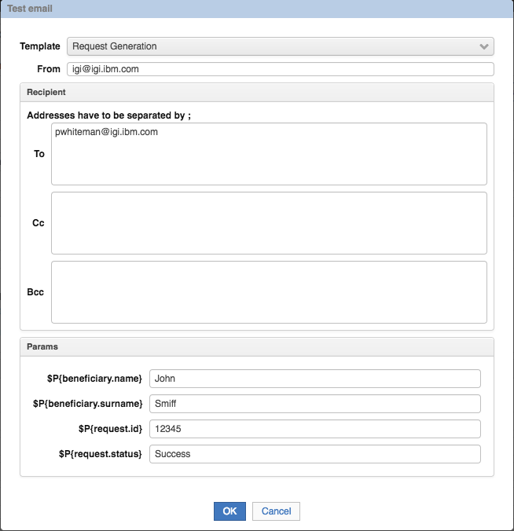

It is important that the email address is [pwhiteman@igi.ibm.com](mailto:pwhiteman@igi.ibm.com) or the test won’t work.

* Click **OK**
* On the Information dialog, click **OK**.

This will send an email to the SMTP server on the VM and if you’ve got your email client configured correctly you will see an email sent to Patricia.

It may take some minutes for the email to be sent and arrive. Like many things in IGI, the email mechanism relies on a task that runs periodically.

You can move to the next part of the lab and come back to your email client to check if the email has been received. The email should look like this:

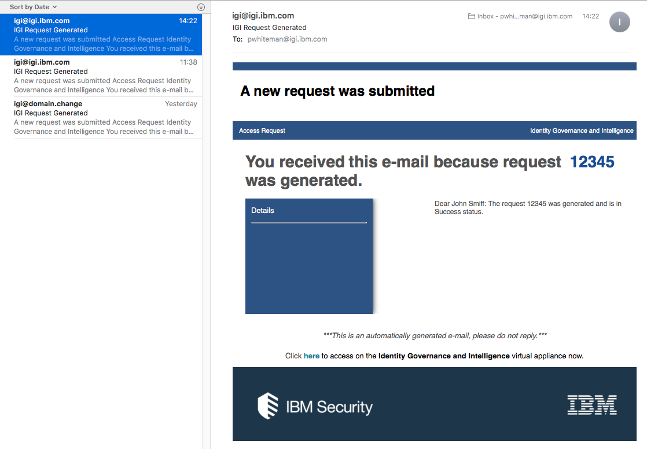

If you don’t see this after 15 minutes, check your email client configuration.

### Explore the Notification Templates tab

We will now explore the Notification Templates tab.

* Click on the **Notification Templates** link.

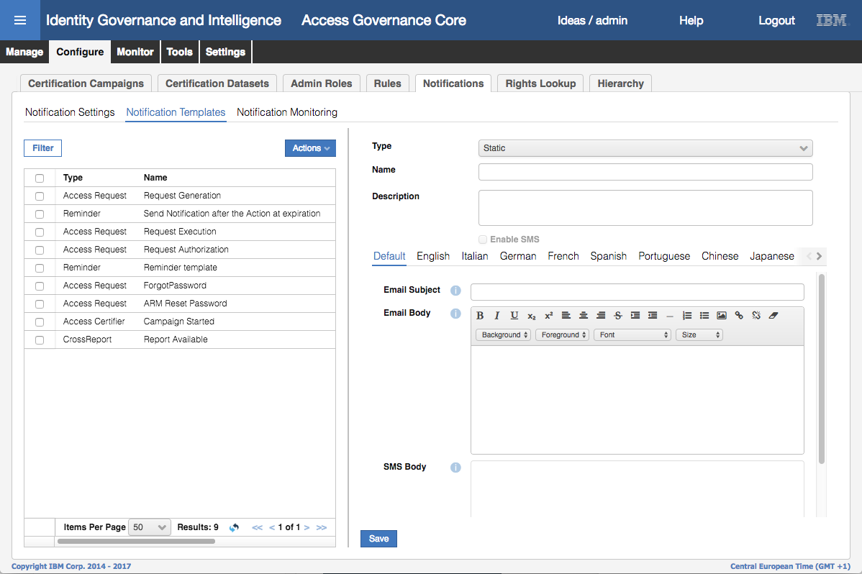

The left pane shows the Notification Templates configured. For example, for Access Requests there are templates for Request Generation, Request Authorization, Request Execution, Forgot Password and ARM Reset Password.

The right pane shows the details for each template:

* Type – for example Access Request
* Name – name of the template
* Description – description of the template
* Enable SMS – whether SMS is enabled
* Email and SMS details with individual language tabs based on the languages enabled in IGI
  + Email subject – the subject that will be used in the SMTP message
  + Email body – the body of the email
  + SMS Body (not shown above) – the text in the SMS

The language tabs can be used to specify different template subject/body based on language.

If you change the Default template, you also need to change any language-specific templates you intend to use. For example, if English is used, changes need to be applied to the Default and the English templates.

More information can be found in the IGI documentation on the Knowledge Center.

* Select any of the templates and use the scroll bar to have a look at the email body.

It provides a WYSIWYG editor with the ability to add images, change fonts, add links etc. (we will use this in a later part of this lab). Note that the templates use variables like $P{beneficiary.surname} to define specific content at generation time. These are documented in the IGI documentation on the Knowledge Center.

### Explore the Notification Monitoring tab

We will now explore the Notification Monitoring tab.

* Click on the **Notification Monitoring** link.

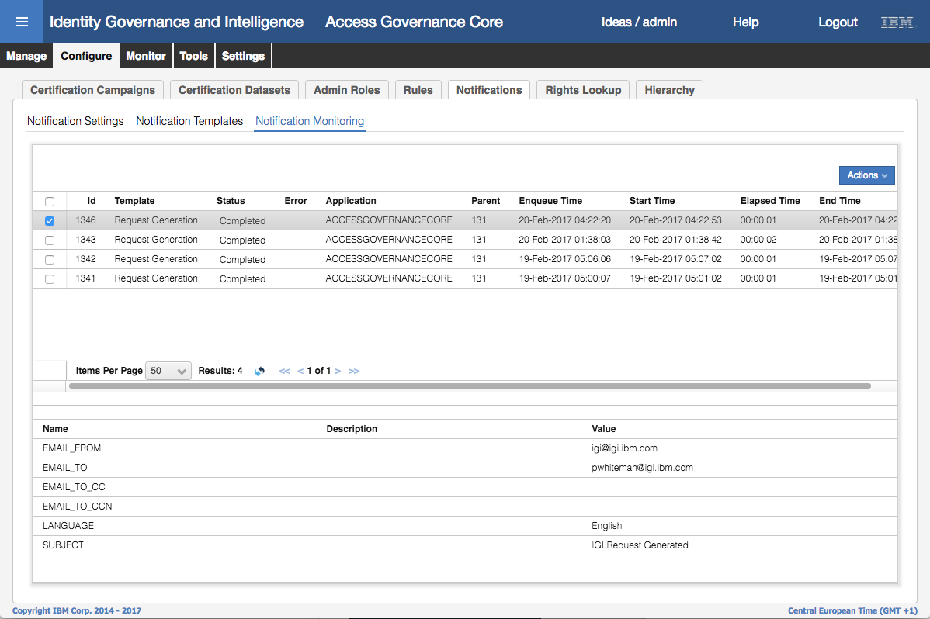

This tab shows all email (and SMS) notifications generated. The top one should correspond to the test email you sent in the earlier step.

* Select the most recent (top) email.

The bottom pane shows the summary information for the email (not the body).

* If you haven’t already done it, check that the email has arrived in your email client.

With a familiarity of the Notification system and your email client working, we can move onto the next part of the lab that will use some of these templates.

## Part 2 – Add Notifications to an Access Request Workflow

This part of the lab will add notifications to activities in the self-service access request workflow and test it’s working.

### Open the Process Designer

The steps are:

* If not already there, open the **IGI Administrative Console** (admin/admin)
* Open **Process Designer** (you can go directly from the Home page or use the Menu)
* Go to **Manage** and select the Access Request [Personal] process
* Put the process into Maintenance Mode (**Actions > Maintenance**)
* Select the **Configuration** tab on the right pane

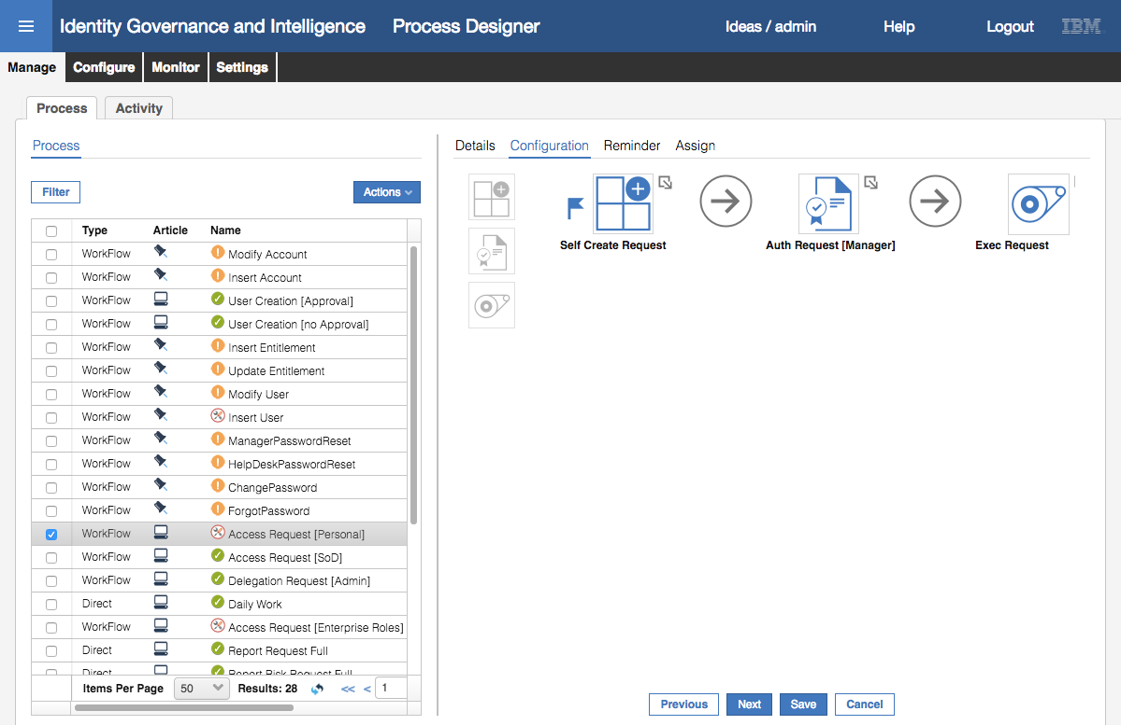

This process (the workflow for a self-service access request) has three activities; Self Create Request (the *Generate* activity), Auth Request [Manager] (the *Authorize* activity) and the Exec Request (the *Execute* activity).

We’re going to add email notifications to the generate and authorize activities, to email notifications after the activity has been completed.

### Add Notification to the Activities

* Right-click the arrow to the right of the Self Create Request activity and select **Add > Notification**

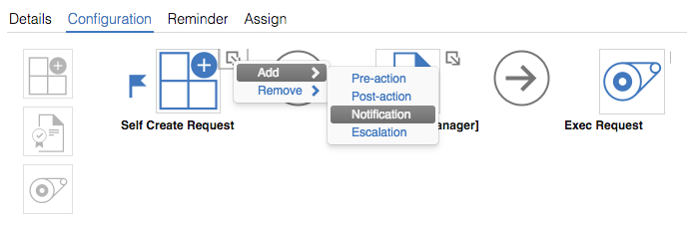

The notification dialog is shown.

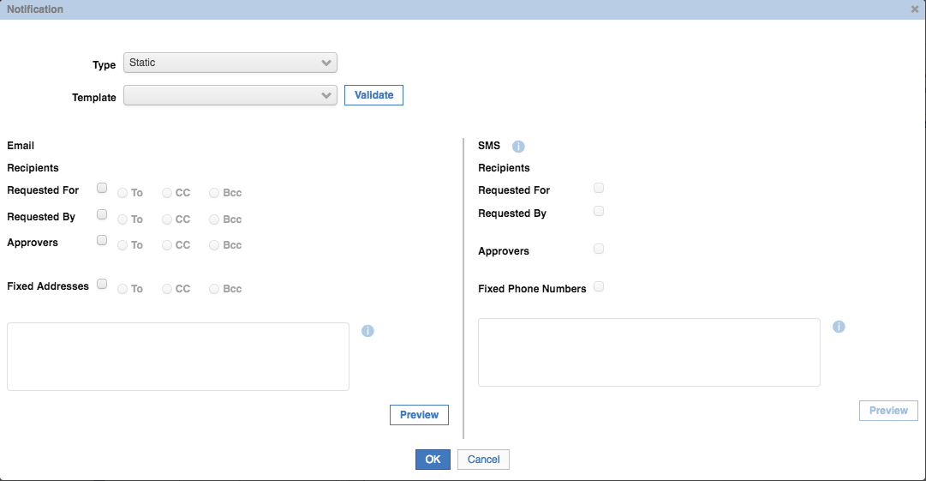

We aren’t concerned with the SMS settings (SMS is not enabled anyway). We want to send an email to the person the access is being requested for, and copy the person requesting it (which will be the same person as this is a self-service request. The **Type** is Access Request, and the **Template** is Request Generation.

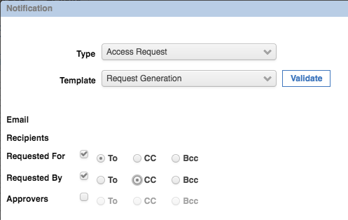

We are deliberately leaving off the Approvers. The reason for this will be explained later.

* Enter the details as show above
* Click the **Preview** button to get a preview of the email body

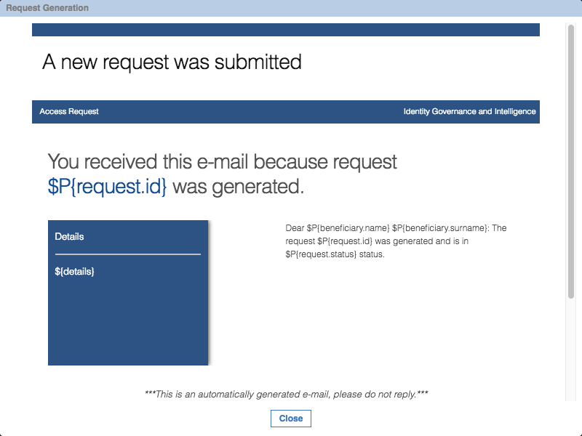

* Click **Close** on the Request Generation dialog
* Click **OK** on the Notification dialog

The Self Create Request activity will have a small mail icon beside the main icon.

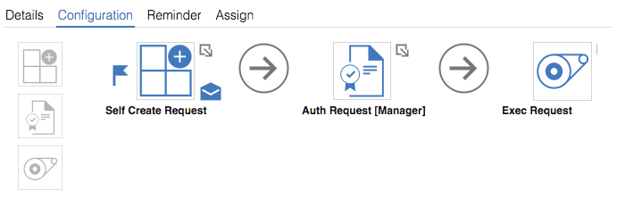

We will now repeat the above steps for the Auth Request [Manager] activity.

* Right-click the arrow to the right of the Auth Request [Manager] activity and select Add > Notification
* Repeat the steps from before, setting the **Type** to Access Request, the **Template** to Request Authorization, and the email recipients as above.

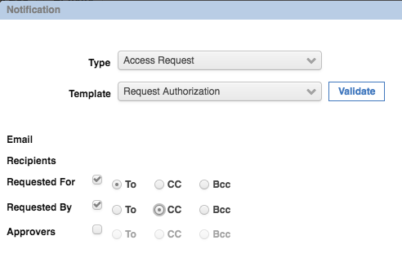

* Click **OK** on the Notification dialog

The Auth Request [Manager] activity will have a small mail icon beside the main icon.

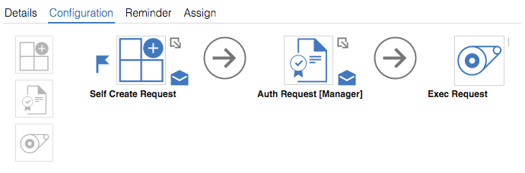

* Click **Save** to save the workflow process changes (don’t forget this step)
* Put the process back in online mode (**Actions > Online**)

The Process Designer UI will allow you to add notifications to activities with the process still online. However the changes will not be saved against the process.

This completes the steps to add the email notifications to the activities. The next section will test that it’s working.

### Test the Notification Configuration

In this section, we will test the new notifications on the self-service access request. The steps assume you are familiar with the IGI Service Center and the Access Request functions and we won’t provide detailed steps or screen shots, except where it’s relevant for the notification functionality.

* Log into the **Service Center** as Patricia Whiteman (PWhiteman / Passw0rd)
* Go to **Access Requests**
* Select a permission to add (e.g. GenSys / projects_south_region) and submit it. It doesn’t matter what permission you assign, we’re just showing notifications.
* Go to **My Request** and check that the access request has been submitted. Note the Request ID and Sub-Request ID (e.g. 439, 440)

Before approving the request, we’ll have a look at the email notification from the generate activity.

* Log into the **Administration Console** (admin / admin)
* Go to **Access Governance Core > Configure > Notifications**
* Go to the **Notification Monitoring** tab. You should see a new ACCESSREQUESTS email there for the template “Request Generation”

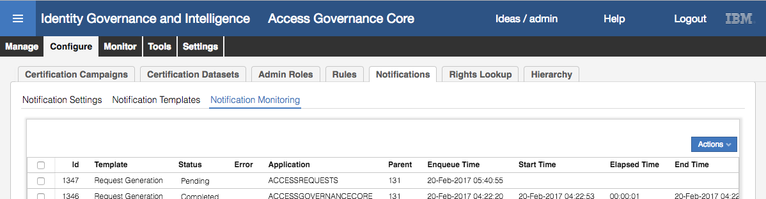

If it’s showing as Pending, that means the email task hasn’t picked it up yet. Click on the refresh icon at the bottom of the top pane and it will (eventually) change to Completed.

* Select the new notification and look at the details in the bottom pane.

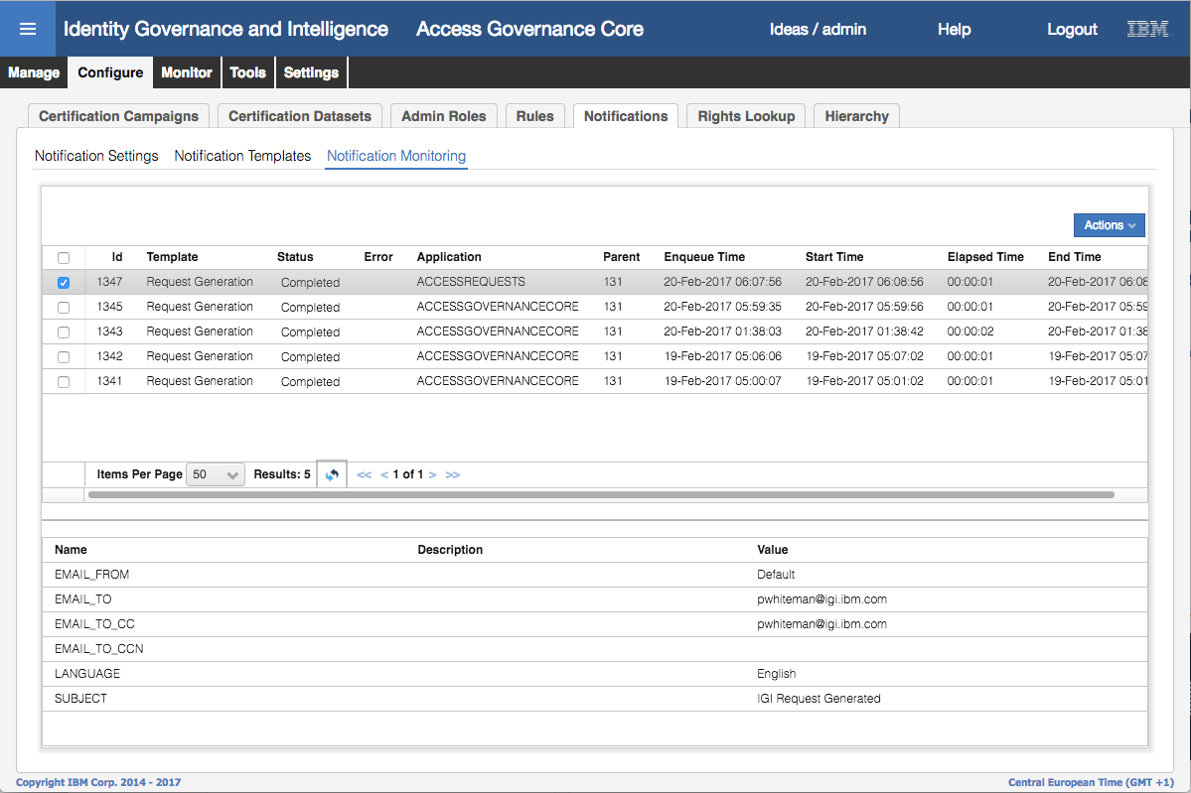

We deliberately left the Approvers off the To/Copy lists as the SMTP/IMAP servers on the VM have a problem when the lists include non-local addresses. This is just an issue with the lab environment.

You might see an email appear soon after the notification changes to Completed, but we’ll leave checking the emails until the end. For now, we will complete the workflow.

* Login to the **Service Center** as David Fox (DFox / Passw0rd)
* Go to **Access Requests > User Manager > Daily Work** and find the request (it should be at the top)
* Reject the request (so we can repeat it a little bit later)
* Log into the **Administration Console** (admin / admin)
* Go to **Access Governance Core > Configure > Notifications**
* Go to the **Notification Monitoring** tab. You should see a new ACCESSREQUESTS email there, this time for the template “Request Authorization”.
* Click the refresh button until it changes to Completed.

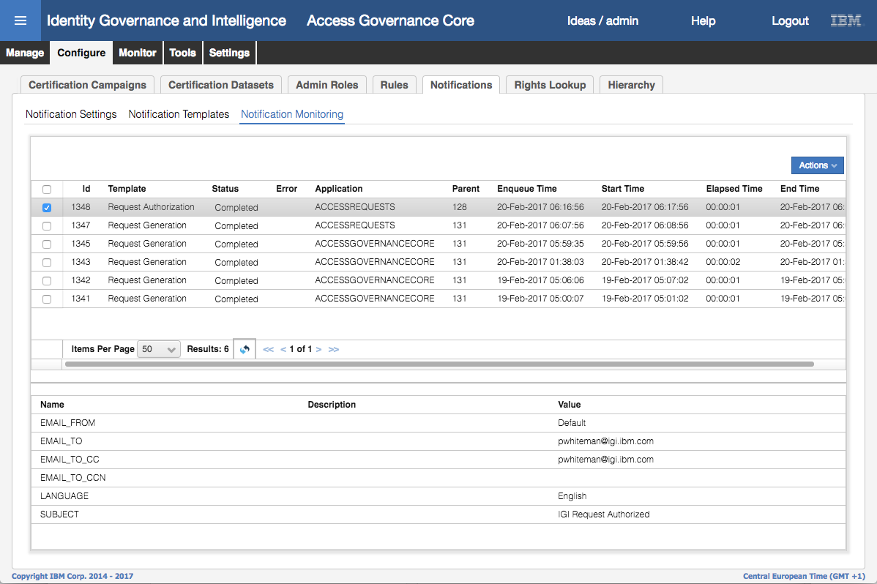

* Go to your email client. You should see two emails there, one titled “IGI Request Generated” and one titled “IGI Request Authorized”.

The display will be different to the below depending on what email client you’re using and the request ids for your transaction. However, you should see two emails one for the request generation and one for the request authorization.

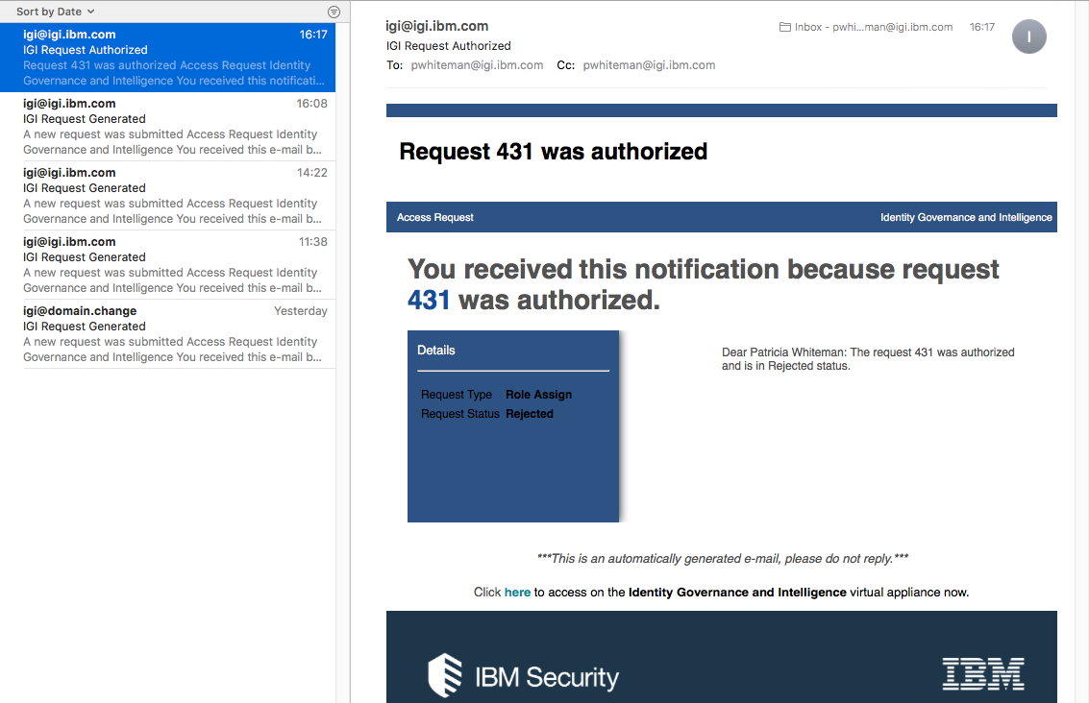

* Have a look at the content (body) of the email. Do you think it could be improved?
* Click on the “**here**” link in the “Click here to access on the ….” line. Does it work?

In the next section of the lab, we will modify one of the templates to make it more usable.

## Part 3 - Modify Templates and Test

In this part of the lab we will modify the Request Generation and Request Authorize templates.

### Modify the Request Generation Template

The steps are

* Repeat the steps from the earlier section to go to the **Notification Templates** tab in **Access Governance Core > Configure > Notifications** (**Administration Console**, admin / admin)
* Select the Access Request / Request Generation template
* Change the **Default** template text…

Some suggestions are:

1. Change:

Dear $P{beneficiary.name} $P{beneficiary.surname}: The request$P{request.id} was generated and is in $P{request.status} status.

to:

Dear $P{beneficiary.name} $P{beneficiary.surname}: Your access request was generated and is in $P{request.status} status.

If you did not request this change, please contact your manager or the HelpDesk on 555-1234.

1. Change:

Click **here** to access on the Identity Governance and Intelligence virtual appliance now.

To:

Click **here** to access the Identity Governance and Intelligence application now.

Be careful how you change the text. You may get unexpected results if you move the text around accidentally.

* Double-click the word (or select the entire word) “**here**” in the “Click **here** to access…” line.
* Click on the link icon (bit of chain, see pic below)
* Set the link to https://192.168.42.60:9343

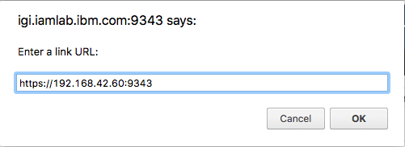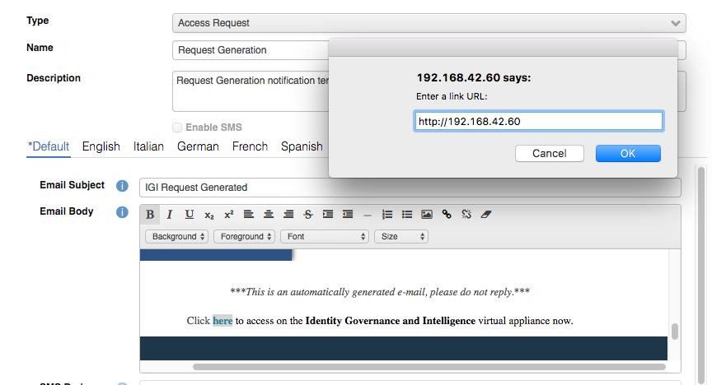

* Click **OK** on the link dialog
* Click **Save** on the template page
* Click **OK** on the Information dialog
* Repeat the above steps for the **English** version of the template.
* Repeat the above steps for the Access Request / Request Authorization template (both **Default** and **English** versions). Make sure you save your changes.

We’re now ready to test the changes.

### Test the Template Modifications

* Repeat the **Access Request** steps in the Service Center with Patricia Whiteman (PWhiteman / Passw0rd) requesting access and David Fox (DFox / Passw0rd) reviewing access (he can approve or reject the request).
* Go back into the **Administrative Console** (admin / admin), go to **Access Governance Core > Configure > Notifications**, select the **Notification Monitoring** tab

You should see the email notifications as before.

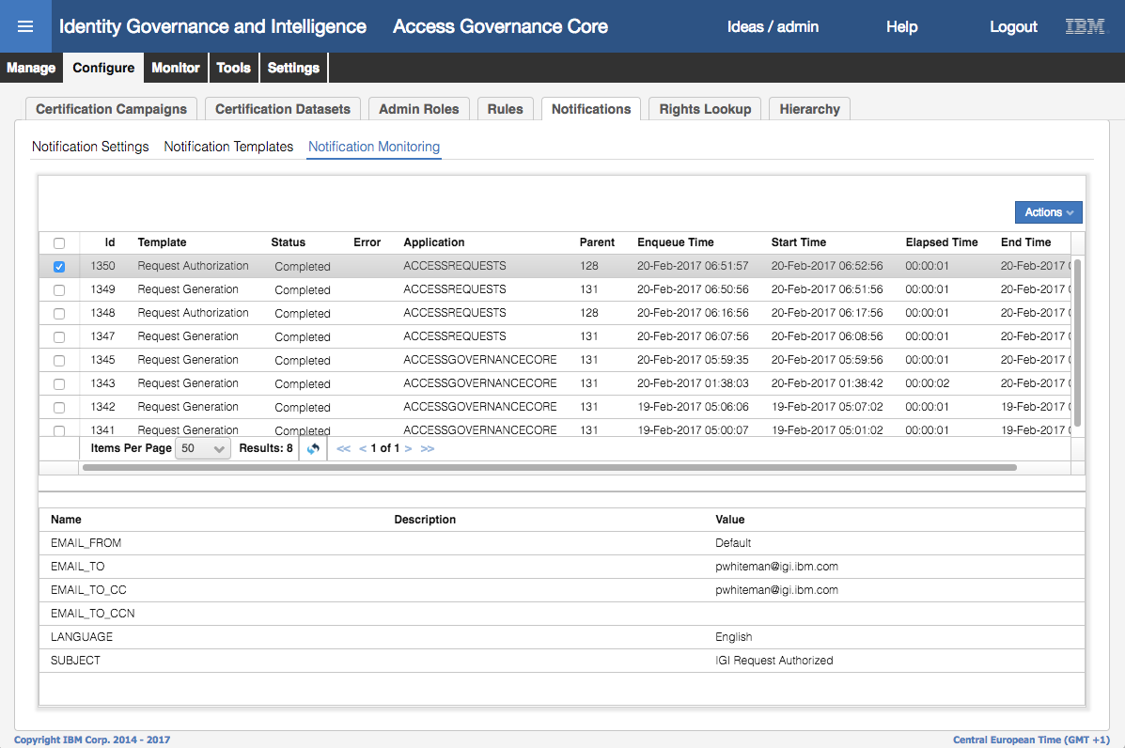

* Go to your email client and check the two emails have arrived.

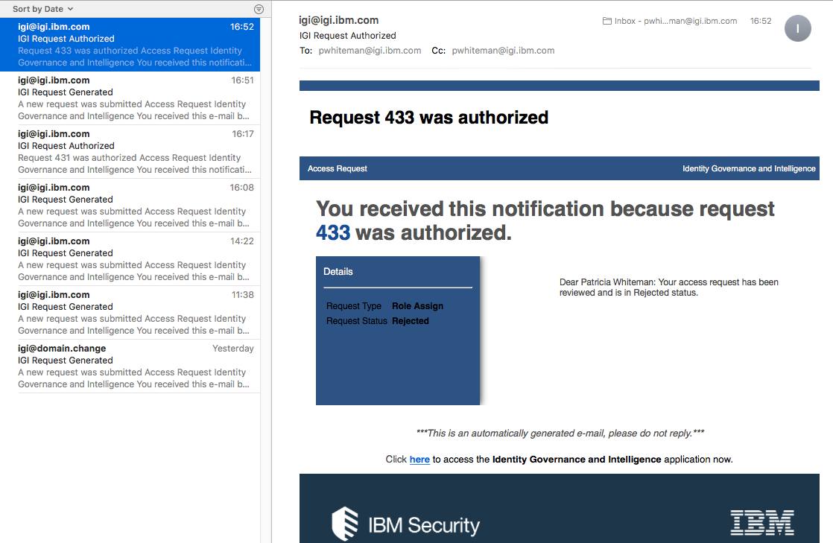

Notice that the text of the email has changed (“Dear Patricia Whiteman: Your access request has been reviewed and is in Rejected status”). You should also see any other changes (like that additional line about contacting the HelpDesk). The line at the bottom has also changed.

You could change almost all content in the email, including fonts, colours, graphics and layout.

* Click on the “**here**” link. You should be taken to a browser with the IGI Landing page.

This last change is only required as we are not using the Virtual Appliance. If the Virtual Appliance was in use, the link would be correct and not need changing.

This completes the email notification lab.

End of Document

# Notices

This information was developed for products and services offered in the U.S.A. IBM may not offer the products, services, or features discussed in this document in other countries. Consult your local IBM representative for information on the products and services currently available in your area. Any reference to an IBM product, program, or service is not intended to state or imply that only that IBM product, program, or service may be used. Any functionally equivalent product, program, or service that does not infringe any IBM intellectual property right may be used instead. However, it is the user's responsibility to evaluate and verify the operation of any non-IBM product, program, or service.

IBM may have patents or pending patent applications covering subject matter described in this document. The furnishing of this document does not give you any license to these patents. You can send license inquiries, in writing, to:

IBM Director of Licensing  
IBM Corporation  
North Castle Drive  
Armonk, NY 10504-1785 U.S.A.

For license inquiries regarding double-byte character set (DBCS) information, contact the IBM Intellectual Property Department in your country or send inquiries, in writing, to:

Intellectual Property Licensing  
Legal and Intellectual Property Law  
IBM Japan, Ltd.  
19-21, Nihonbashi-Hakozakicho, Chuo-ku  
Tokyo 103-8510, Japan

**The following paragraph does not apply to the United Kingdom or any other country where such provisions are inconsistent with local law :**

INTERNATIONAL BUSINESS MACHINES CORPORATION PROVIDES THIS PUBLICATION "AS IS" WITHOUT WARRANTY OF ANY KIND, EITHER EXPRESS OR IMPLIED, INCLUDING, BUT NOT LIMITED TO, THE IMPLIED WARRANTIES OF NON-INFRINGEMENT, MERCHANTABILITY OR FITNESS FOR A PARTICULAR PURPOSE.

Some states do not allow disclaimer of express or implied warranties in certain transactions, therefore, this statement might not apply to you.

This information could include technical inaccuracies or typographical errors. Changes are periodically made to the information herein; these changes will be incorporated in new editions of the publication. IBM may make improvements and/or changes in the product(s) and/or the program(s) described in this publication at any time without notice.

Any references in this information to non-IBM Web sites are provided for convenience only and do not in any manner serve as an endorsement of those Web sites. The materials at those Web sites are not part of the materials for this IBM product and use of those Web sites is at your own risk.

IBM may use or distribute any of the information you supply in any way it believes appropriate without incurring any obligation to you.

Licensees of this program who wish to have information about it for the purpose of enabling: (i) the exchange of information between independently created programs and other programs (including this one) and (ii) the mutual use of the information which has been exchanged, should contact:

IBM Corporation  
2Z4A/101  
11400 Burnet Road  
Austin, TX 78758 U.S.A.

Such information may be available, subject to appropriate terms and conditions, including in some cases payment of a fee.

The licensed program described in this document and all licensed material available for it are provided by IBM under terms of the IBM Customer Agreement, IBM International Program License Agreement or any equivalent agreement between us.

Any performance data contained herein was determined in a controlled environment. Therefore, the results obtained in other operating environments may vary significantly. Some measurements may have been made on development-level systems and there is no guarantee that these measurements will be the same on generally available systems. Furthermore, some measurement may have been estimated through extrapolation. Actual results may vary. Users of this document should verify the applicable data for their specific environment.

Information concerning non-IBM products was obtained from the suppliers of those products, their published announcements or other publicly available sources. IBM has not tested those products and cannot confirm the accuracy of performance, compatibility or any other claims related to non-IBM products. Questions on the capabilities of non-IBM products should be addressed to the suppliers of those products.

All statements regarding IBM's future direction or intent are subject to change or withdrawal without notice, and represent goals and objectives only.

All IBM prices shown are IBM's suggested retail prices, are current and are subject to change without notice. Dealer prices may vary.

This information is for planning purposes only. The information herein is subject to change before the products described become available.

This information contains examples of data and reports used in daily business operations. To illustrate them as completely as possible, the examples include the names of individuals, companies, brands, and products. All of these names are fictitious and any similarity to the names and addresses used by an actual business enterprise is entirely coincidental.

**COPYRIGHT LICENSE:**

This information contains sample application programs in source language, which illustrate programming techniques on various operating platforms. You may copy, modify, and distribute these sample programs in any form without payment to IBM, for the purposes of developing, using, marketing or distributing application programs conforming to the application programming interface for the operating platform for which the sample programs are written. These examples have not been thoroughly tested under all conditions. IBM, therefore, cannot guarantee or imply reliability, serviceability, or function of these programs. You may copy, modify, and distribute these sample programs in any form without payment to IBM for the purposes of developing, using, marketing, or distributing application programs conforming to IBM's application programming interfaces.

Each copy or any portion of these sample programs or any derivative work, must include a copyright notice as follows:

© IBM 2017. Portions of this code are derived from IBM Corp. Sample Programs. © Copyright IBM Corp 2017. All rights reserved.

If you are viewing this information in softcopy form, the photographs and color illustrations might not be displayed.

**Trademarks**

IBM, the IBM logo, and ibm.com are trademarks or registered trademarks of International Business Machines Corp., registered in many jurisdictions worldwide. Other product and service names might be trademarks of IBM or other companies. A current list of IBM trademarks is available on the Web at Copyright and trademark information at ibm.com/legal/copytrade.shtml.

**Statement of Good Security Practices**

IT system security involves protecting systems and information through prevention, detection and response to improper access from within and outside your enterprise. Improper access can result in information being altered, destroyed, misappropriated or misused or can result in damage to or misuse of your systems, including for use in attacks on others. No IT system or product should be considered completely secure and no single product, service or security measure can be completely effective in preventing improper use or access. IBM systems, products and services are designed to be part of a comprehensive security approach, which will necessarily involve additional operational procedures, and may require other systems, products or services to be most effective. IBM DOES NOT WARRANT THAT ANY SYSTEMS, PRODUCTS OR SERVICES ARE IMMUNE FROM, OR WILL MAKE YOUR ENTERPRISE IMMUNE FROM, THE MALICIOUS OR ILLEGAL CONDUCT OF ANY PARTY.

© International Business Machines Corporation 2017

International Business Machines Corporation  
New Orchard Road Armonk, NY 10504

Produced in the United States of America 01-2016

All Rights Reserved

References in this publication to IBM products and services do not imply that IBM intends to make them available in all countries in which IBM operates.